1. Move and Turn
2. Import Starter Assets from XR Interaction Toolkit Samples
3. Copy the XR Origin from the Starter Assets to the Courtyard Setup scene.
4. Keep only the necessary components.

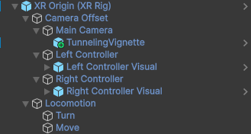

1. Push Button
2. Copy the Prefab Push Button from the Starter Assets to the Courtyard Setup scene

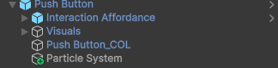

1. Add Interactable Events to control the triggering of the Particle System.

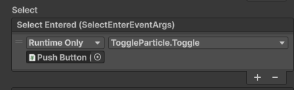

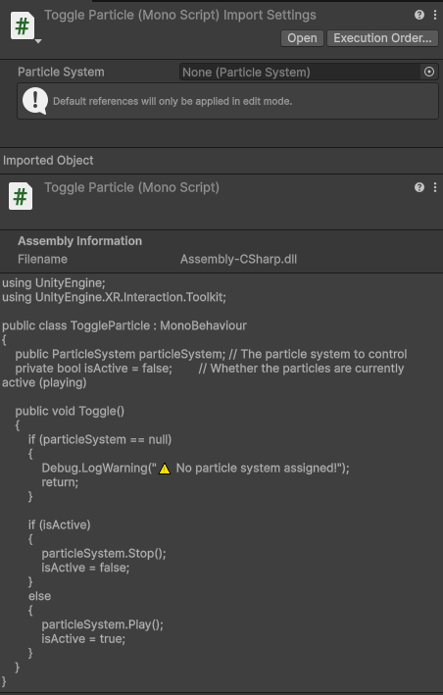

1. Add Near-Far Interactor to enable pressing the Push Button from both near and far distances.

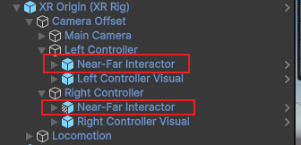

1. UI
2. Copy the Prefab UI from the Starter Assets to the Courtyard Setup scene

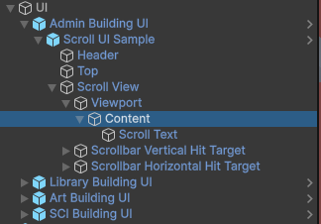

1. Modify the text of Header and Scroll Content.

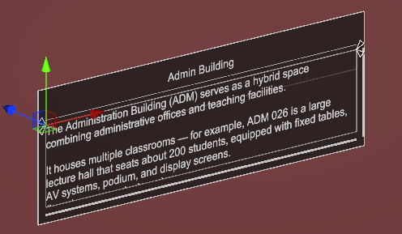

1. Modify Position and Rotation to place it in the desired location.

